Step 1: Importing Instagram Analysis file

import pandas as pd
import numpy as np
import matplotlib.pyplot as plt
import seaborn as sns
df = pd.read_excel('/instagram_analysis_unique_users.xlsx')
df
 | Username | Post_Type | Hashtag | Location | Device | Gender | Followers | Following | Likes | Comments | Shares | Saves | Views | Post_Date | Engagement_Rate
0 | user_0001 | Photo | #travel | Delhi | iPhone | Female | 94931 | 72 | 1392 | 266 | 235 | 67 | 32450 | 2024-01-01 | 14.85
1 | user_0002 | Carousel | #art | Tokyo | Web | Other | 92187 | 4028 | 2583 | 415 | 962 | 998 | 53579 | 2024-01-02 | 8.44
2 | user_0003 | Photo | #travel | Mumbai | Android | Female | 83190 | 1219 | 6129 | 439 | 575 | 856 | 12359 | 2024-01-03 | 3.45
3 | user_0004 | Photo | #art | Paris | Web | Other | 4293 | 3120 | 5117 | 197 | 838 | 223 | 14223 | 2024-01-04 | 14.05
4 | user_0005 | Carousel | #food | Tokyo | Android | Other | 54988 | 3090 | 2959 | 428 | 216 | 544 | 9358 | 2024-01-05 | 9.40
... | ... | ... | ... | ... | ... | ... | ... | ... | ... | ... | ... | ... | ... | ... | ...
1195 | user_1196 | Carousel | #funny | Mumbai | Web | Other | 43937 | 2848 | 4098 | 257 | 181 | 994 | 21947 | 2027-04-10 | 9.58
1196 | user_1197 | Carousel | #art | Tokyo | Android | Male | 78447 | 1607 | 5148 | 358 | 104 | 729 | 56925 | 2027-04-11 | 1.08
1197 | user_1198 | Story | #music | Paris | Android | Female | 39979 | 160 | 2419 | 32 | 983 | 907 | 94548 | 2027-04-12 | 10.83
1198 | user_1199 | Story | #fashion | Sydney | Web | Male | 24507 | 3711 | 9517 | 453 | 305 | 576 | 51786 | 2027-04-13 | 14.28
1199 | user_1200 | Carousel | #funny | Sydney | Web | Female | 30804 | 4269 | 5398 | 258 | 437 | 454 | 83822 | 2027-04-14 | 5.67

: Step 2: Importing Information

df.info()

<class 'pandas.core.frame.DataFrame'>
RangeIndex: 1200 entries, 0 to 1199
Data columns (total 15 columns):
# Column Non-Null Count Dtype
--- ------ -------------- -----
0 Username 1200 non-null object
1 Post_Type 1200 non-null object
2 Hashtag 1200 non-null object
3 Location 1200 non-null object
4 Device 1200 non-null object
5 Gender 1200 non-null object
6 Followers 1200 non-null int64
7 Following 1200 non-null int64
8 Likes 1200 non-null int64
9 Comments 1200 non-null int64
10 Shares 1200 non-null int64
11 Saves 1200 non-null int64
12 Views 1200 non-null int64
13 Post_Date 1200 non-null datetime64[ns]
14 Engagement_Rate 1200 non-null float64
dtypes: datetime64[ns](1), float64(1), int64(7), object(6)
memory usage: 140.8+ KB
Step 3: After Removing Duplicates

df = df.drop_duplicates()
print(f"Number of rows after removing duplicates: {len(df)}")

Number of rows after removing duplicates: 1200
df.duplicated().sum()

np.int64(0)
df['Gender'].duplicated().sum()

np.int64(1197)

def conv(x):
if x == 'Male':
return 0
elif x == 'Female':
return 1
else:
return 2
ax = sns.countplot(x='Gender', data=df)
plt.title('Gender Distribution')
ax.bar_label(ax.containers[0])
plt.show()

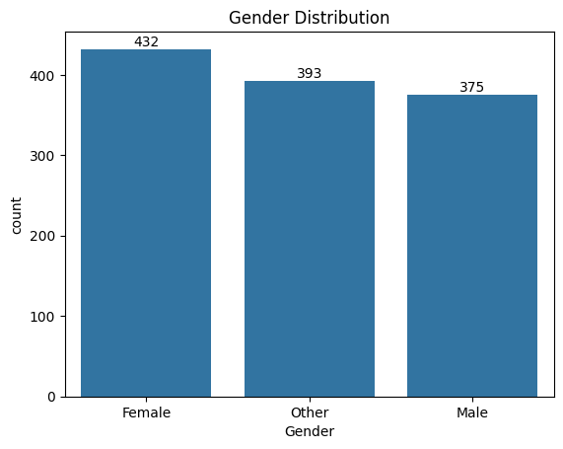

Step 4: Distribution Of Locations

location_counts = df['Location'].value_counts()

plt.figure(figsize=(8, 8))
plt.pie(location_counts, labels=location_counts.index, autopct='%1.1f%%', startangle=140)
plt.title('Distribution of User Locations')
plt.axis('equal') # Equal aspect ratio ensures that pie is drawn as a circle.
plt.show()

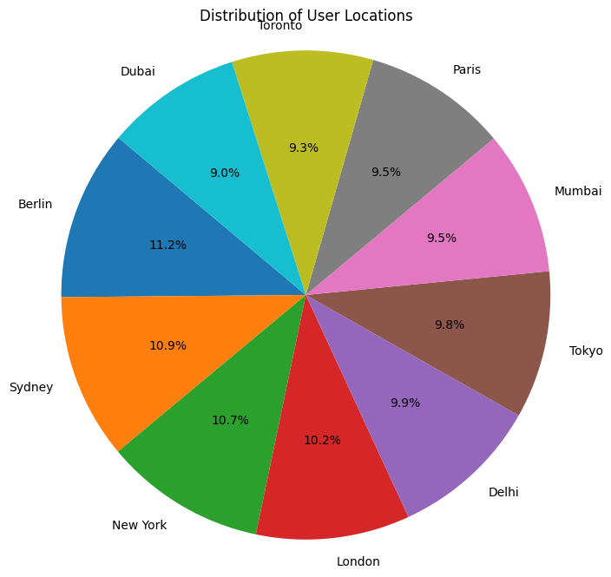
Step 5: Distribution of Followers

plt.figure(figsize=(10, 6))
sns.histplot(x='Followers', data=df, bins=20, kde=True)
plt.title('Distribution of Followers')
plt.xlabel('Followers')
plt.ylabel('Frequency')
plt.show()

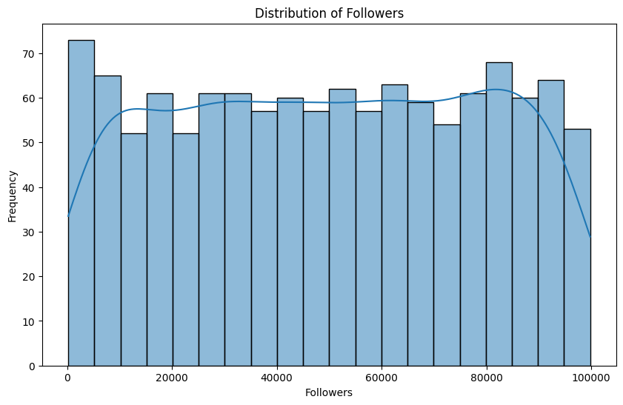

Step 6: By Gender Distributing the Post Types

# Create a crosstab of 'Post_Type' and 'Gender' to count the combinations
crosstab = pd.crosstab(df['Post_Type'], df['Gender'])

# Plot a stacked bar chart
ax = crosstab.plot(kind='bar', stacked=True, figsize=(10, 6))

# Add percentage labels on each segment
for c in ax.containers:
labels = [f'{w/c.datavalues.sum():0.1%}' if (w := v.get_height()) > 0 else '' for v in c]
ax.bar_label(c, labels=labels, label_type='center')

# Set the title and labels
plt.title('Distribution of Post Types by Gender')
plt.xlabel('Post Type')
plt.ylabel('Count')
plt.xticks(rotation=0)
plt.legend(title='Gender')

# Display the plot
plt.show()

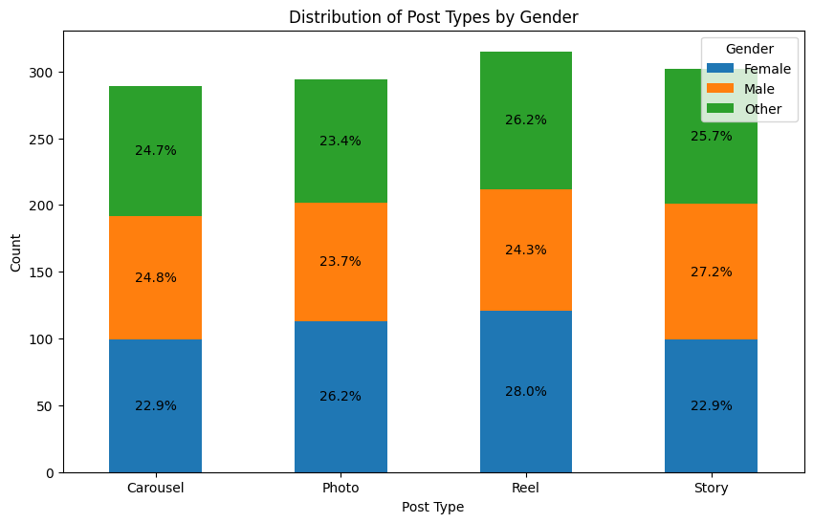
Step 7: Distribution of Devices for Photo Post Types

# Filter the DataFrame for 'Photo' post types
photo_df = df[df['Post_Type'] == 'Photo']

# Create a crosstab of 'Post_Type' and 'Device' to count the combinations
crosstab_photo_device = pd.crosstab(photo_df['Post_Type'], photo_df['Device'])

# Plot a stacked bar chart
ax = crosstab_photo_device.plot(kind='bar', stacked=True, figsize=(10, 6))

# Add percentage labels on each segment
for c in ax.containers:
labels = [f'{w/c.datavalues.sum():0.1%}' if (w := v.get_height()) > 0 else '' for v in c]
ax.bar_label(c, labels=labels, label_type='center')

# Set the title and labels
plt.title('Distribution of Devices for Photo Post Types')
plt.xlabel('Post Type')
plt.ylabel('Count')
plt.xticks(rotation=0)
plt.legend(title='Device')

# Display the plot
plt.show()
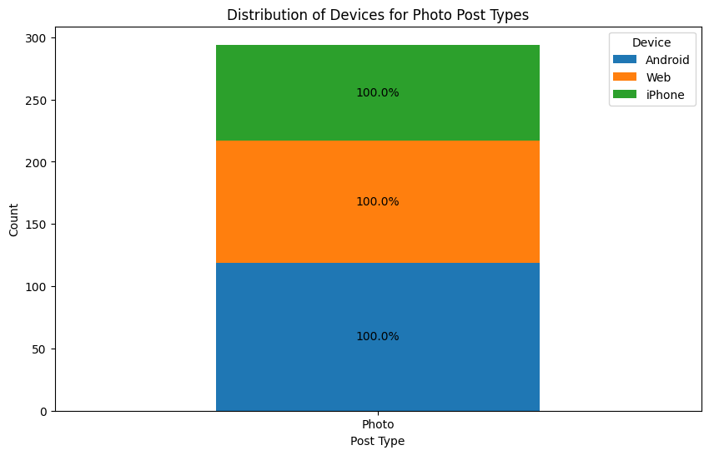

Step 8: Distribution of Columns

df.columns.values

array(['Username', 'Post_Type', 'Hashtag', 'Location', 'Device', 'Gender',
'Followers', 'Following', 'Likes', 'Comments', 'Shares', 'Saves',
'Views', 'Post_Date', 'Engagement_Rate'], dtype=object
# Print the names of the columns in the DataFrame
print("Columns in the DataFrame:")
print(df.columns.values)

# Select only numerical columns for plotting
numerical_cols = df.select_dtypes(include=np.number).columns

# Create a figure and a set of subplots
# Adjusting the grid size based on the number of numerical columns
n_cols = 3
n_rows = (len(numerical_cols) + n_cols - 1) // n_cols

plt.figure(figsize=(15, n_rows * 5)) # Adjust figure size based on rows

for i,col in enumerate(numerical_cols):
plt.subplot(n_rows, n_cols, i+1)
sns.histplot(x=col, data=df, kde=True)
plt.title(f'Distribution of {col}')
plt.xlabel(col)
plt.ylabel('Frequency')

plt.tight_layout()
plt.show()

Columns in the DataFrame:
['Username' 'Post_Type' 'Hashtag' 'Location' 'Device' 'Gender' 'Followers'
'Following' 'Likes' 'Comments' 'Shares' 'Saves' 'Views' 'Post_Date'
'Engagement_Rate']
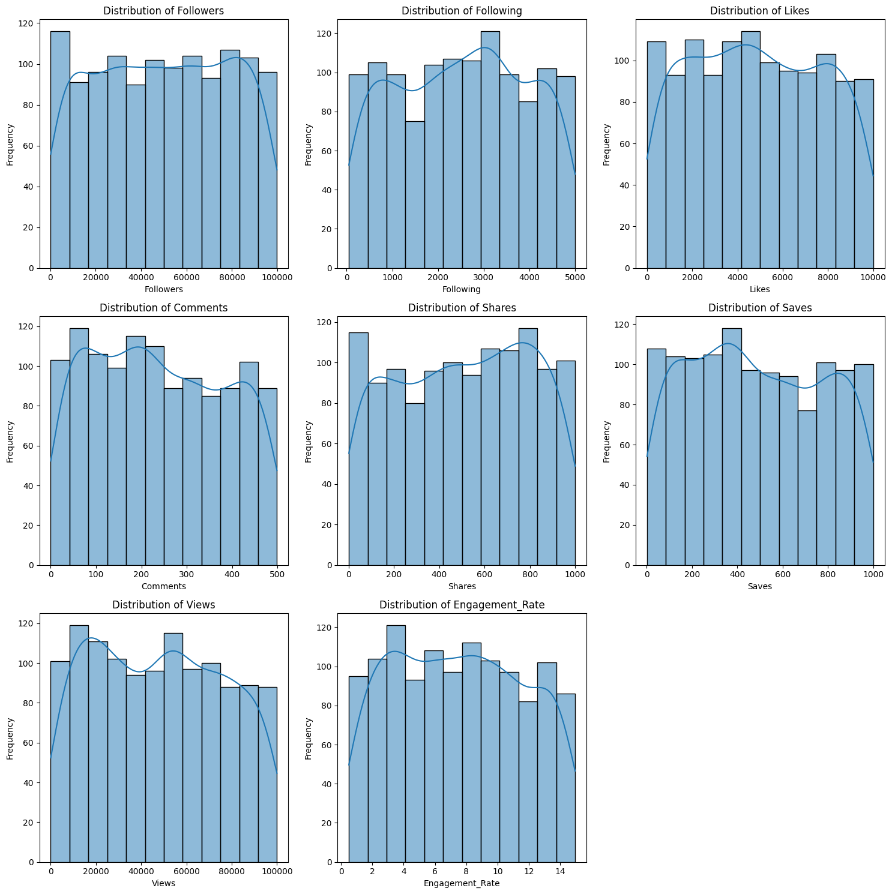

Step 9: Plotting Scatter Chart to find the difference between Engagement rate and Followers

plt.figure(figsize=(10, 6))
sns.scatterplot(x='Followers', y='Engagement_Rate', data=df)
plt.title('Engagement Rate vs. Followers')
plt.xlabel('Followers')
plt.ylabel('Engagement Rate')
plt.show()

